Ahmed Elnaggar

Ahmed.elnaggar20@imperial.ac.uk

01863407

Yussef Noemen

yussef.noeman20@imperial.ac.uk

The cavity problem: computing coursework

.

# Navier-Stokes equations

**1.1 Conservation of Mass**

The mass conservation states that the rate of accumulation of mass in a volume V is exactly balanced by the mass flux across its boundary S; it expresses as

$\frac{∂}{∂t}\int{ρdv}+\int_{s}{ρn∙udS}=0$ (1)

where ρ is the density and **u** the fluid velocity vector. The surface integral in Eq. (1) can be converted into a volume integral by Gauss’ divergence theorem2, hence Eq. (1) can be written as:

$\int_{V}{\left[\frac{∂}{∂t}+∇∙\left(ρu\right)\right]}dV=0$ (2)

which gives the integral form of mass conservation. From now on we further assume that all functions considered are continuous and sufficiently differentiable. Since V is arbitrary, we must have

$\frac{∂ρ}{∂t}+∇∙\left(ρu\right)=0$ (3)

By simple vector analysis, Eq. (3) implies

$\frac{∂ρ}{∂t}+u∙∇ρ+ρ∇∙u=0$ (4)

or

$\frac{Dρ}{Dt}+u∇∙u=0$ (5)

where $\frac{Dρ}{Dt}=\frac{∂ρ}{∂t}+u∙∇ρ$ is called the material derivative or substantial derivative of ρ. The material derivative is often used in fluid dynamics, which specifies the rate of change of a physical quantity when moving with the fluid flow.

The Eqs. (3) and (5) are often referred to as forms of the continuity equation. If the fluid is incompressible, the density ρ is constant with respect to both space and time, hence $\frac{Dρ}{Dt}=0$ and

$∇∙u=0$ (6)

which is the incompressibility condition for the flow field.

**1.2 Conservation of Momentum**

The conservation of momentum states that the rate of accumulation of momentum in V plus the flux of momentum out through S is equal to the rate of gain of momentum due to body forces and surface stresses. Mathematically it leads to

$\frac{∂}{∂t}\int_{V}{ρudV}+\int_{S}{ρ\left(n∙u\right)udS}=\int_{V}{ρfdV}+\int_{S}{n∙σdS}$ (7)

where f is the body force and σ is the stress tensor. Using Gauss’ divergence theorem, Eq. (7) yields

$\int_{V}{\left[\frac{∂}{∂t}\left(ρu\right)+∇∙\left(ρuu\right)\right]dV}=\int_{V}{\left(ρf+∇∙σ \right)dV}$ (8)

where **uu** stands for the dyadic or tensor product. From Eq. (8), we again use the argument that the volume V is arbitrary to obtain

$\frac{∂}{∂t}\left(ρu\right)+∇∙\left(ρuu\right)=ρf+∇∙σ$ (9)

and by vector analysis

$u\frac{∂ρ}{∂t}+ρ\frac{∂u}{∂t}+ρu∙∇u+u∇∙\left(ρu\right)=ρf+∇∙σ$ (10)

The continuity Eq. (3) implies that the first and last terms on the left-hand side of Eq. (10) must cancel, hence

$ρ\frac{∂u}{∂t}+ρu∙∇u=ρf+∇∙σ$ (11)

In the case of an incompressible fluid with constant viscosity,

$σ=-P+μ∇u$ (12)

After neglecting the body forces and substituting Eq (12) in Eq (11), the equation of motion reduces to

$\frac{∂u}{∂t}+u∙∇u=-\frac{∇P}{ρ}+ν{∇ }^{2}u$ (13)

where $ν=\frac{μ}{ρ}$ is called kinematic viscosity. The Eq. (13) is one of the most frequently encountered governing equation in fluid dynamics, known as the Navier-Stokes equation, which was derived independently by Claude-Louis Navier (1785-1836), and George Gabriel Stokes (1819-1903). In the literature, Eqs. (6) and (13) are jointly referred to as the Navier-Stokes equations for viscous incompressible flow.

# Poisson Equation

For a moment, recall the Navier–Stokes equations for an incompressible fluid, where u represents the velocity field:

$∇∙u=0$ (6)

$\frac{∂u}{∂t}+u∙∇u=-\frac{∇P}{ρ}+ν{∇ }^{2}u$ (13)

The first equation represents mass conservation at constant density. The second equation is the conservation of momentum. But a problem appears: the continuity equation for incompressible flow does not have a dominant variable and there is no obvious way to couple the velocity and the pressure. In the case of compressible flow, in contrast, mass continuity would provide an evolution equation for the density ρ, which is coupled with an equation of state relating ρ and p.

In incompressible flow, the continuity equation $∇∙u=0$ provides a kinematic constraint that requires the pressure field to evolve so that the rate of expansion $∇∙u$ should vanish everywhere. A way out of this difficulty is to construct a pressure field that guarantees continuity is satisfied; such a relation can be obtained by taking the divergence of the momentum equation. In that process, a Poisson equation for the pressure shows up!

Continuity and momentum equation in 2D for incompressible flow as follow:

$\frac{∂u}{∂x}+\frac{∂v}{∂y}=0$ (14)

$\frac{∂u}{∂t}+u\frac{∂u}{∂x}+v\frac{∂u}{∂y}=-\frac{1}{ρ}\frac{∂P}{∂x}+ν\left(\frac{∂^{2}u}{∂x^{2}}+\frac{∂^{2}u}{∂y^{2}}\right)$ (15)

$\frac{∂v}{∂t}+u\frac{∂v}{∂x}+v\frac{∂v}{∂y}=-\frac{1}{ρ}\frac{∂P}{∂y}+ν\left(\frac{∂^{2}v}{∂x^{2}}+\frac{∂^{2}v}{∂y^{2}}\right)$ (16)

Which are three equations in the three unknows (u,v,P).

Differentiate momentum equation in x -direction with respect to x and momentum equation in y direction with respect to y to get the following:

$\frac{\text{∂}}{\text{∂t}}\left(\frac{\text{∂u}}{\text{∂x}}\right)\text{+}\frac{\text{∂u}}{\text{∂x}}\frac{\text{∂u}}{\text{∂x}}\text{+u}\frac{{\text{∂}}^{\text{2}}\text{u}}{\text{∂}{\text{x}}^{\text{2}}}\text{+}\frac{\text{∂v}}{\text{∂x}}\frac{\text{∂u}}{\text{∂y}}\text{+v}\frac{{\text{∂}}^{\text{2}}\text{u}}{\text{∂}\text{x∂y}}\text{=-}\frac{\text{1}}{\text{ρ}}\frac{{\text{∂}}^{\text{2}}\text{P}}{\text{∂}{\text{x}}^{\text{2}}}\text{+ν}\frac{\text{∂}}{\text{∂x}}\left(\frac{{\text{∂}}^{\text{2}}\text{u}}{\text{∂}{\text{x}}^{\text{2}}}\text{+}\frac{{\text{∂}}^{\text{2}}\text{u}}{\text{∂}{\text{y}}^{\text{2}}}\right)$ (17)

$\frac{\text{∂}}{\text{∂t}}\left(\frac{\text{∂v}}{\text{∂y}}\right)\text{+}\frac{\text{∂u}}{\text{∂y}}\frac{\text{∂v}}{\text{∂x}}\text{+u}\frac{{\text{∂}}^{\text{2}}\text{v}}{\text{∂}\text{x∂y}}\text{+}\frac{\text{∂v}}{\text{∂y}}\frac{\text{∂v}}{\text{∂y}}\text{+v}\frac{{\text{∂}}^{\text{2}}\text{v}}{\text{∂}{\text{y}}^{\text{2}}}\text{=-}\frac{\text{1}}{\text{ρ}}\frac{{\text{∂}}^{\text{2}}\text{P}}{\text{∂}{\text{y}}^{\text{2}}}\text{+ν}\frac{\text{∂}}{\text{∂y}}\left(\frac{{\text{∂}}^{\text{2}}\text{v}}{\text{∂}{\text{x}}^{\text{2}}}\text{+}\frac{{\text{∂}}^{\text{2}}\text{v}}{\text{∂}{\text{y}}^{\text{2}}}\right)$ (18)

Sum equations (17) + (18)

$L.H.S.=\frac{\text{∂}}{\text{∂t}}\left(\frac{\text{∂u}}{\text{∂x}}+\frac{\text{∂v}}{\text{∂y}}\right)\text{+}{\left(\frac{\text{∂u}}{\text{∂x}}\right)}^{2}\text{+}\frac{\text{∂u}}{\text{∂y}}\frac{\text{∂v}}{\text{∂x}}\text{+}\left(\text{u}\frac{{\text{∂}}^{\text{2}}\text{u}}{\text{∂}{\text{x}}^{\text{2}}}+\text{v}\frac{{\text{∂}}^{\text{2}}\text{u}}{\text{∂}{\text{y}}^{\text{2}}}\right)\text{+}{\left(\frac{\text{∂v}}{\text{∂y}}\right)}^{2}\text{+}\frac{\text{∂u}}{\text{∂y}}\frac{\text{∂v}}{\text{∂x}}\text{+}\left(\text{v}\frac{{\text{∂}}^{\text{2}}\text{u}}{\text{∂}\text{x∂y}}\text{+u}\frac{{\text{∂}}^{\text{2}}\text{v}}{\text{∂}\text{x∂y}}\right)$

$L.H.S.=\frac{\text{∂}}{\text{∂t}}\left(\frac{\text{∂u}}{\text{∂x}}+\frac{\text{∂v}}{\text{∂y}}\right)\text{+}{\left(\frac{\text{∂u}}{\text{∂x}}\right)}^{2}\text{+2*}\frac{\text{∂u}}{\text{∂y}}\frac{\text{∂v}}{\text{∂x}}\text{+}{\left(\frac{\text{∂v}}{\text{∂y}}\right)}^{2}\text{+u}\frac{\text{∂}}{\text{∂x}}\left(\frac{\text{∂u}}{\text{∂x}}+\frac{\text{∂v}}{\text{∂y}}\right)\text{+v}\frac{\text{∂}}{\text{∂y}}\left(\frac{\text{∂u}}{\text{∂x}}+\frac{\text{∂v}}{\text{∂y}}\right)$

$from continuity equation \frac{\text{∂u}}{\text{∂x}}+\frac{\text{∂v}}{\text{∂y}}\text{=0}$

$L.H.S.={\left(\frac{\text{∂u}}{\text{∂x}}\right)}^{2}\text{+2*}\frac{\text{∂u}}{\text{∂y}}\frac{\text{∂v}}{\text{∂x}}\text{+}{\left(\frac{\text{∂v}}{\text{∂y}}\right)}^{2}$

$R.H.S.=\text{-}\frac{\text{1}}{\text{ρ}}\left(\frac{{\text{∂}}^{\text{2}}\text{P}}{\text{∂}{\text{x}}^{\text{2}}}\text{+}\frac{{\text{∂}}^{\text{2}}\text{P}}{\text{∂}{\text{y}}^{\text{2}}}\right)\text{+ν}\left[\frac{\text{∂}}{\text{∂x}}\left(\frac{{\text{∂}}^{\text{2}}\text{u}}{\text{∂}{\text{x}}^{\text{2}}}\text{+}\frac{{\text{∂}}^{\text{2}}\text{u}}{\text{∂}{\text{y}}^{\text{2}}}\right)+\frac{\text{∂}}{\text{∂y}}\left(\frac{{\text{∂}}^{\text{2}}\text{v}}{\text{∂}{\text{x}}^{\text{2}}}\text{+}\frac{{\text{∂}}^{\text{2}}\text{v}}{\text{∂}{\text{y}}^{\text{2}}}\right)\right]$

$R.H.S.=\text{-}\frac{\text{1}}{\text{ρ}}\left(\frac{{\text{∂}}^{\text{2}}\text{P}}{\text{∂}{\text{x}}^{\text{2}}}\text{+}\frac{{\text{∂}}^{\text{2}}\text{P}}{\text{∂}{\text{y}}^{\text{2}}}\right)\text{+ν}\left[\frac{{\text{∂}}^{\text{3}}\text{u}}{\text{∂}{\text{x}}^{\text{3}}}+\frac{{\text{∂}}^{\text{3}}\text{u}}{\text{∂}{\text{x∂y}}^{\text{2}}}++\frac{{\text{∂}}^{\text{3}}\text{v}}{{\text{∂x}}^{\text{2}}∂y}+\frac{{\text{∂}}^{\text{3}}\text{v}}{\text{∂}{\text{y}}^{\text{3}}}\right]$

$R.H.S.=\text{-}\frac{\text{1}}{\text{ρ}}\left(\frac{{\text{∂}}^{\text{2}}\text{P}}{\text{∂}{\text{x}}^{\text{2}}}\text{+}\frac{{\text{∂}}^{\text{2}}\text{P}}{\text{∂}{\text{y}}^{\text{2}}}\right)\text{+ν}\left[\frac{\text{∂}}{\text{∂}{\text{x}}^{\text{2}}}\left(\frac{\text{∂u}}{\text{∂x}}+\frac{\text{∂v}}{\text{∂y}}\right)+\frac{\text{∂}}{\text{∂}{\text{y}}^{\text{2}}}\left(\frac{\text{∂u}}{\text{∂x}}+\frac{\text{∂v}}{\text{∂y}}\right)\right]$

$from continuity equation \frac{\text{∂u}}{\text{∂x}}+\frac{\text{∂v}}{\text{∂y}}\text{=0}$

$R.H.S.=\text{-}\frac{\text{1}}{\text{ρ}}\left(\frac{{\text{∂}}^{\text{2}}\text{P}}{\text{∂}{\text{x}}^{\text{2}}}\text{+}\frac{{\text{∂}}^{\text{2}}\text{P}}{\text{∂}{\text{y}}^{\text{2}}}\right)$

So Poisson Equation (L.H.S = R.H.S.):

$\text{-}\frac{\text{1}}{\text{ρ}}\left(\frac{{\text{∂}}^{\text{2}}\text{P}}{\text{∂}{\text{x}}^{\text{2}}}\text{+}\frac{{\text{∂}}^{\text{2}}\text{P}}{\text{∂}{\text{y}}^{\text{2}}}\right)= {\left(\frac{\text{∂u}}{\text{∂x}}\right)}^{2}\text{+2*}\frac{\text{∂u}}{\text{∂y}}\frac{\text{∂v}}{\text{∂x}}\text{+}{\left(\frac{\text{∂v}}{\text{∂y}}\right)}^{2}$

Or :

$\frac{{\text{∂}}^{\text{2}}\text{P}}{\text{∂}{\text{x}}^{\text{2}}}\text{+}\frac{{\text{∂}}^{\text{2}}\text{P}}{\text{∂}{\text{y}}^{\text{2}}}=-ρ \left[{\left(\frac{\text{∂u}}{\text{∂x}}\right)}^{2}\text{+2*}\frac{\text{∂u}}{\text{∂y}}\frac{\text{∂v}}{\text{∂x}}\text{+}{\left(\frac{\text{∂v}}{\text{∂y}}\right)}^{2}\right]$ (19)

To assure divergence we can keep the spatial term of continuity equation in Poisson Equation to be

$\frac{{\text{∂}}^{\text{2}}\text{P}}{\text{∂}{\text{x}}^{\text{2}}}\text{+}\frac{{\text{∂}}^{\text{2}}\text{P}}{\text{∂}{\text{y}}^{\text{2}}}=ρ\left[\frac{\text{∂}}{\text{∂t}}\left(\frac{\text{∂u}}{\text{∂x}}+\frac{\text{∂v}}{\text{∂y}}\right)- {\left(\frac{\text{∂u}}{\text{∂x}}\right)}^{2}\text{-2*}\frac{\text{∂u}}{\text{∂y}}\frac{\text{∂v}}{\text{∂x}}\text{-}{\left(\frac{\text{∂v}}{\text{∂y}}\right)}^{2}\right]$ (20)

# Numerical Solution Using Explicit Finite Difference

Here is the system of differential equations: two equations for the velocity components u,v and one equation for pressure:

$\frac{∂u}{∂t}+u\frac{∂u}{∂x}+v\frac{∂u}{∂y}=-\frac{1}{ρ}\frac{∂P}{∂x}+ν\left(\frac{∂^{2}u}{∂x^{2}}+\frac{∂^{2}u}{∂y^{2}}\right)$

$\frac{∂v}{∂t}+u\frac{∂v}{∂x}+v\frac{∂v}{∂y}=-\frac{1}{ρ}\frac{∂P}{∂y}+ν\left(\frac{∂^{2}v}{∂x^{2}}+\frac{∂^{2}v}{∂y^{2}}\right)$

$\frac{{\text{∂}}^{\text{2}}\text{P}}{\text{∂}{\text{x}}^{\text{2}}}\text{+}\frac{{\text{∂}}^{\text{2}}\text{P}}{\text{∂}{\text{y}}^{\text{2}}}=ρ\left[\frac{\text{∂}}{\text{∂t}}\left(\frac{\text{∂u}}{\text{∂x}}+\frac{\text{∂v}}{\text{∂y}}\right)- {\left(\frac{\text{∂u}}{\text{∂x}}\right)}^{2}\text{-2*}\frac{\text{∂u}}{\text{∂y}}\frac{\text{∂v}}{\text{∂x}}\text{-}{\left(\frac{\text{∂v}}{\text{∂y}}\right)}^{2}\right]$

First, let's discretize the u-momentum equation, as follows:

$\frac{u_{i,j}^{n+1}-u_{i,j}^{n}}{∆t}+u_{i,j}^{n}\frac{u_{i,j}^{n}-u_{i-1,j}^{n}}{∆x}+v_{i,j}^{n}\frac{u_{i,j}^{n}-u_{i,j-1}^{n}}{∆y}=-\frac{1}{ρ}\frac{P_{i+1,j}^{n}-P_{i-1,j}^{n}}{2∆x}+ν\left(\frac{u_{i+1,j}^{n}-2u_{i,j}^{n}+u_{i-1,j}^{n}}{∆x^{2}}+\frac{u_{i,j+1}^{n}-2u_{i,j}^{n}+u_{i,j-1}^{n}}{∆y^{2}}\right)$

Similarly for the v-momentum equation:

$\frac{v_{I,j}^{n+1}-v_{I,j}^{n}}{∆t}+u_{I,j}^{n}\frac{v_{I,j}^{n}-v_{i-1,j}^{n}}{∆x}+v_{I,j}^{n}\frac{v_{I,j}^{n}-v_{I,j-1}^{n}}{∆y}=-\frac{1}{ρ}\frac{P_{I,j+1}^{n}-P_{I,j-1}^{n}}{2∆y}+ν\left(\frac{v_{i+1,j}^{n}-2v_{I,j}^{n}+v_{i-1,j}^{n}}{∆x^{2}}+\frac{v_{I,j+1}^{n}-2v_{I,j}^{n}+v_{I,j-1}^{n}}{∆y^{2}}\right)$

Finally, the discretized pressure-Poisson equation can be written thus:

$\frac{P_{i+1,j}^{n}-2P_{I,j}^{n}+P_{i-1,j}^{n}}{∆x^{2}}+\frac{P_{I,j+1}^{n}-2P_{I,j}^{n}+P_{I,j-1}^{n}}{∆y^{2}}=ρ\left[\frac{1}{∆t}\left(\frac{u_{i+1,j}^{n}-u_{i-1,j}^{n}}{2∆x}+\frac{v_{I,j+1}^{n}-v_{I,j-1}^{n}}{2∆y}\right)-\frac{u_{i+1,j}^{n}-u_{i-1,j}^{n}}{2∆x}-2\frac{u_{I,j+1}^{n}-u_{I,j-1}^{n}}{2∆y}\frac{v_{I,j+1}^{n}-v_{I,j-1}^{n}}{2∆y}-\frac{v_{I,j+1}^{n}-v_{I,j-1}^{n}}{2∆y}\frac{v_{I,j+1}^{n}-v_{I,j-1}^{n}}{2∆y}\right]$

Let's rearrange the equations in the way that the iterations need to proceed in the code. First, the momentum equations for the velocity at the next time step.

The momentum equation in the u direction:

$u_{i,j}^{n+1}=u_{i,j}^{n}+∆t\left[-u_{i,j}^{n}\frac{u_{i,j}^{n}-u_{i-1,j}^{n}}{∆x}-v_{i,j}^{n}\frac{u_{i,j}^{n}-u_{i,j-1}^{n}}{∆y}-\frac{1}{ρ}\frac{P_{i+1,j}^{n}-P_{i-1,j}^{n}}{2∆x}+ν\left(\frac{u_{i+1,j}^{n}-2u_{i,j}^{n}+u_{i-1,j}^{n}}{∆x^{2}}+\frac{u_{i,j+1}^{n}-2u_{i,j}^{n}+u_{i,j-1}^{n}}{∆y^{2}}\right)\right]$ (21)

The momentum equation in the v direction:

$v_{i,j}^{n+1}=v_{i,j}^{n}+∆t\left[-u_{i,j}^{n}\frac{v_{i,j}^{n}-v_{i-1,j}^{n}}{∆x}-v_{i,j}^{n}\frac{v_{i,j}^{n}-v_{i,j-1}^{n}}{∆y}-\frac{1}{ρ}\frac{P_{i,j+1}^{n}-P_{i,j-1}^{n}}{2∆y}+ν\left(\frac{v_{i+1,j}^{n}-2v_{i,j}^{n}+v_{i-1,j}^{n}}{∆x^{2}}+\frac{v_{i,j+1}^{n}-2v_{i,j}^{n}+v_{i,j-1}^{n}}{∆y^{2}}\right)\right]$ (22)

Rearrange the pressure-Poisson equation:

$P_{i,j}^{n}=\frac{\left(P_{i+1,j}^{n}+P_{i-1,j}^{n}\right)∆y^{2}+\left(P_{i,j+1}^{n}+P_{i,j-1}^{n}\right)∆x^{2}}{2\left(∆x^{2}+∆y^{2}\right)}-ρ\frac{∆x^{2}∆y^{2}}{2\left(∆x^{2}+∆y^{2}\right)}\left[\frac{1}{∆t}\left(\frac{u_{i+1,j}^{n}-u_{i-1,j}^{n}}{2∆x}+\frac{v_{i,j+1}^{n}-v_{i,j-1}^{n}}{2∆y}\right)-\frac{u_{i+1,j}^{n}-u_{i-1,j}^{n}}{2∆x}-2\frac{u_{i,j+1}^{n}-u_{i,j-1}^{n}}{2∆y}\frac{v_{i,j+1}^{n}-v_{i,j-1}^{n}}{2∆y}-\frac{v_{i,j+1}^{n}-v_{i,j-1}^{n}}{2∆y}\frac{v_{i,j+1}^{n}-v_{i,j-1}^{n}}{2∆y}\right]$ (23)

# Cavity Problem

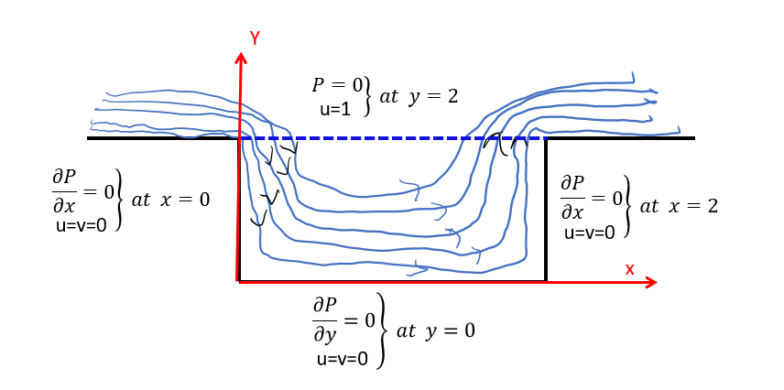

First problem we will assume fluid with viscosity υ = 0.1 with free stream velocity u=1 m/s flow over cavity with 2*2 m dimensions. The boundary condition as shown in the above figure when no slip boundary for velocities u,v in the three solid edges and u=1m at the free stream boundary.

For the pressure, the gradient of the pressure perpendicular to the solid boundaries is zero and the pressure at the free stream is zero.

# The Output

**For kt = 100 (everything else constant)**

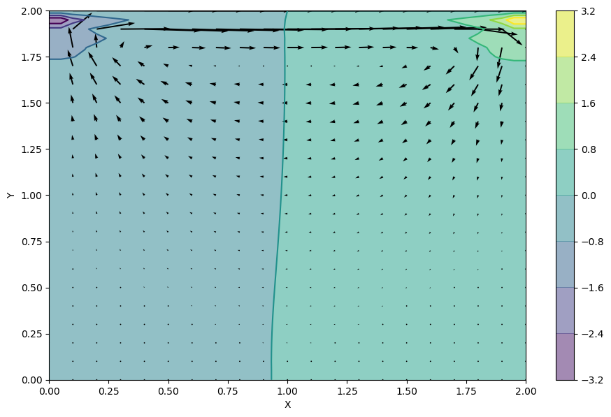

We can see that two distinct pressure zones are forming and that the spiral pattern expected from free stream-driven cavity flow is beginning to form. Experiment with different values of kt to see how long the system takes to stabilize.

**For kx, ky = (10, 10) and kt = 100.**

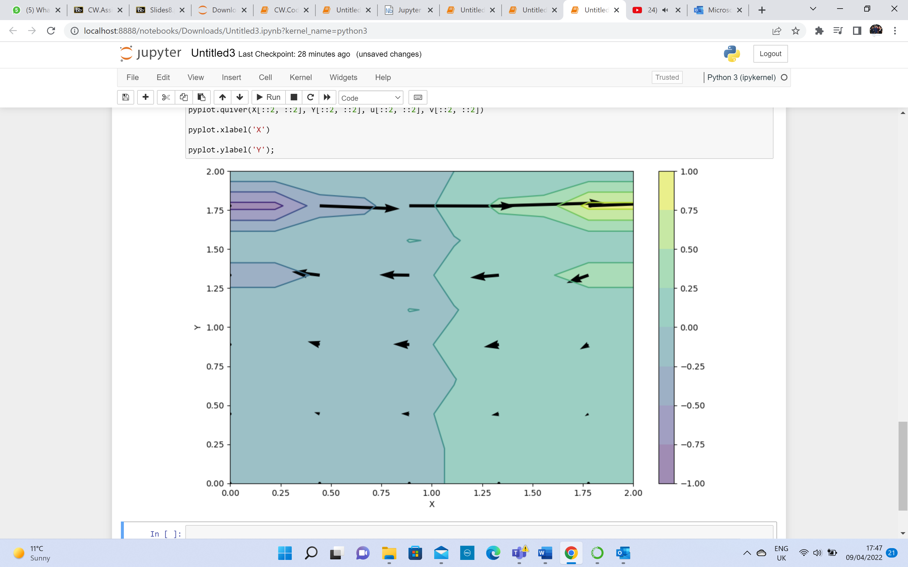

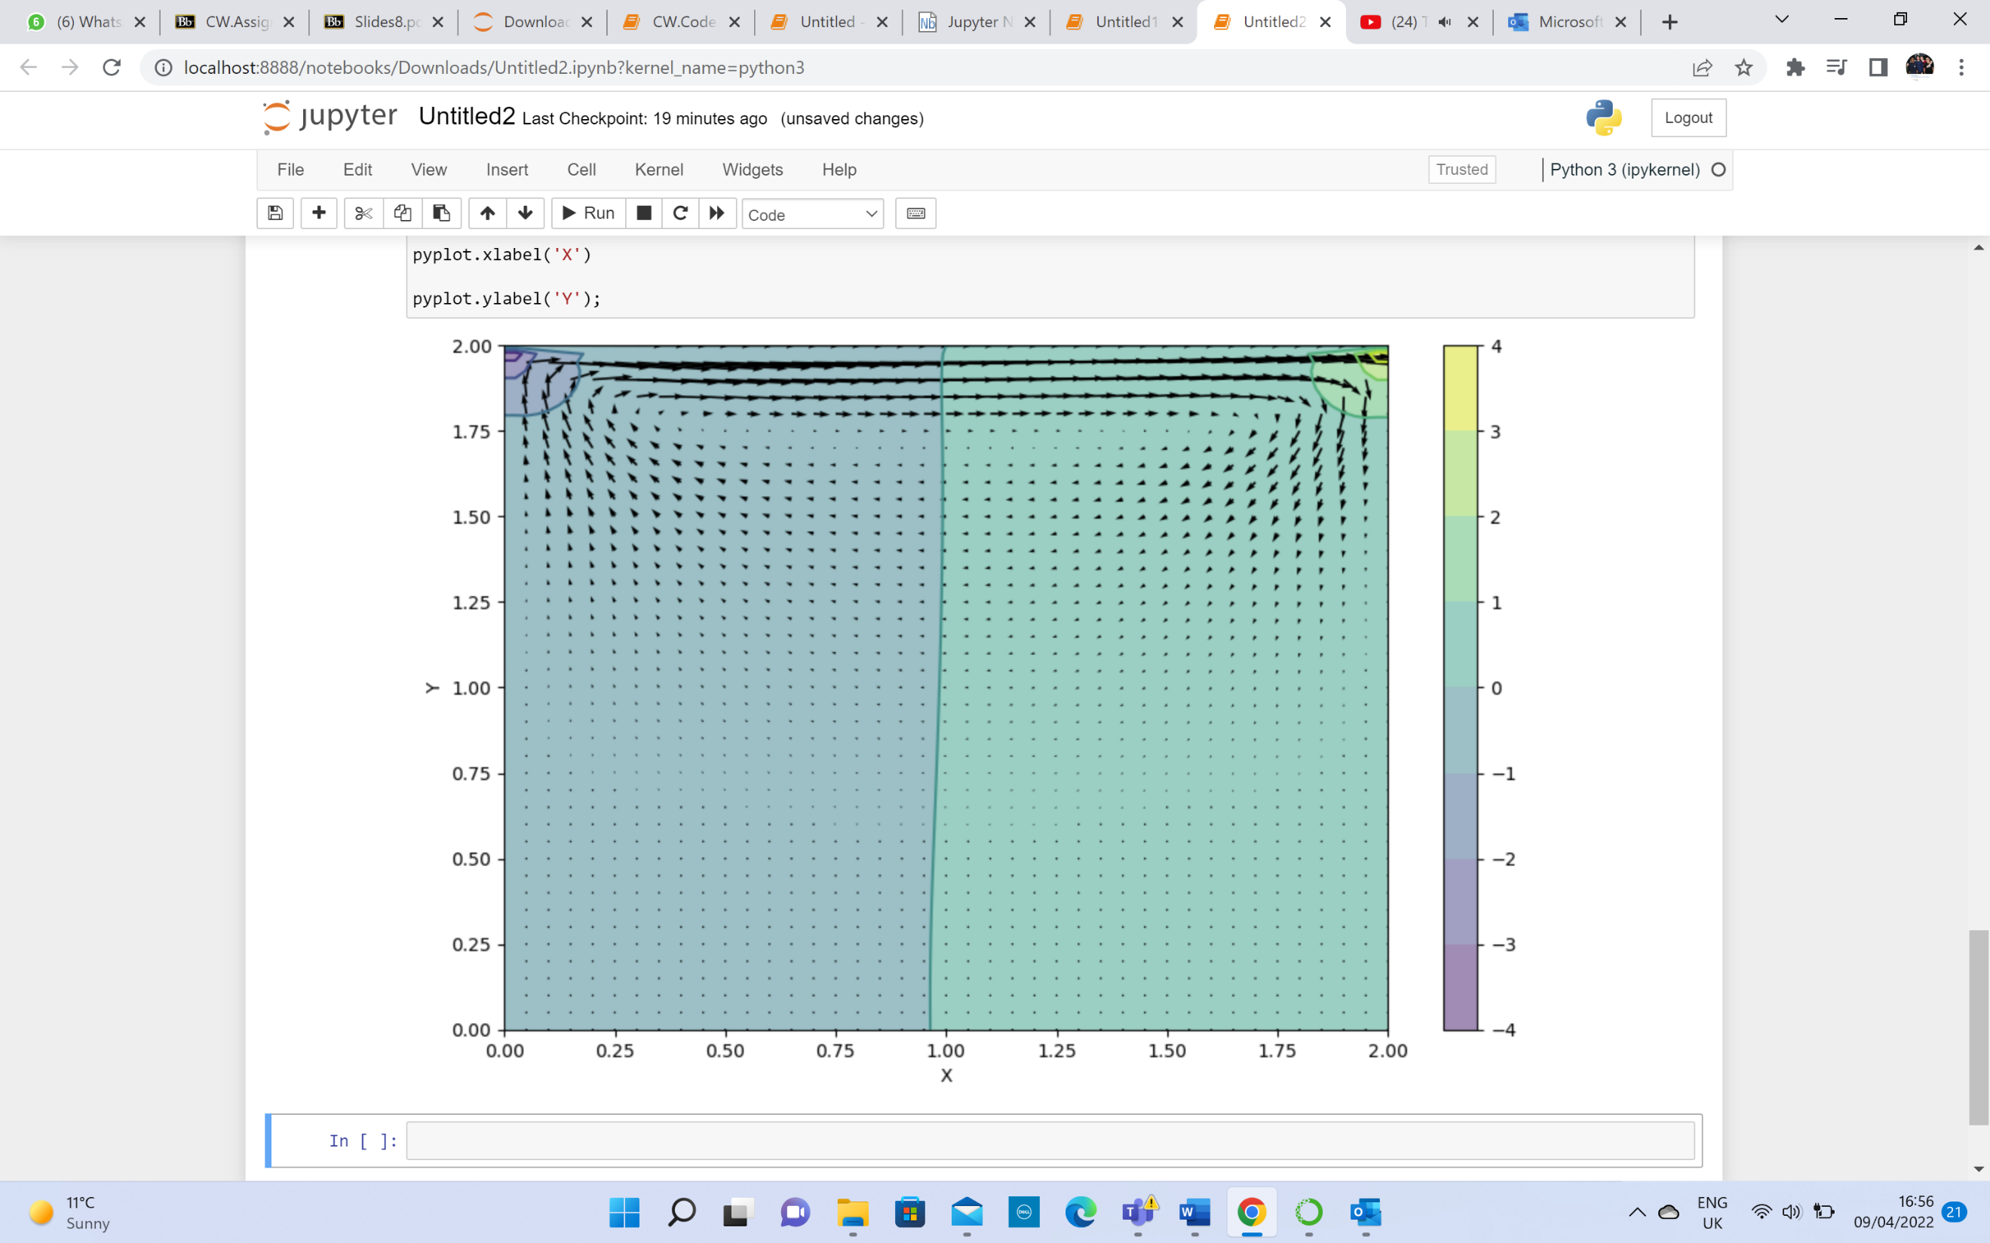**For kx = 81, ky = 81 (instead of 41, 41) and kt = 100 (everything else constant)**

**For kx = 100, ky = 100 and kt = 100 (everything else constant)**

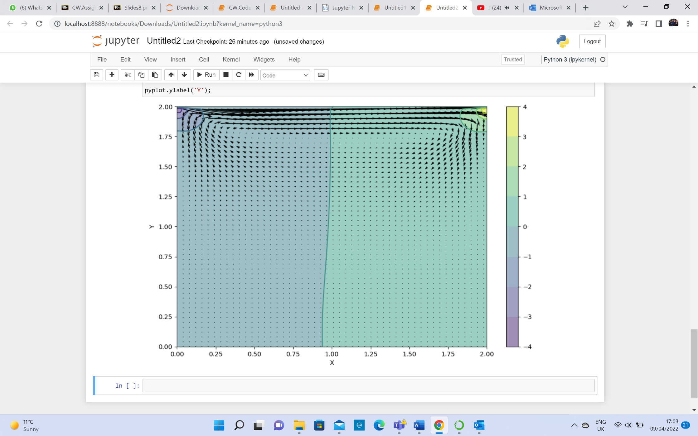

**Note: For kx and ky of 108 or above, and kt of 100, the code can’t run:**

**Threshold:  
For kx and ky = (107, 107) and kt = 100, (and everything else constant).**

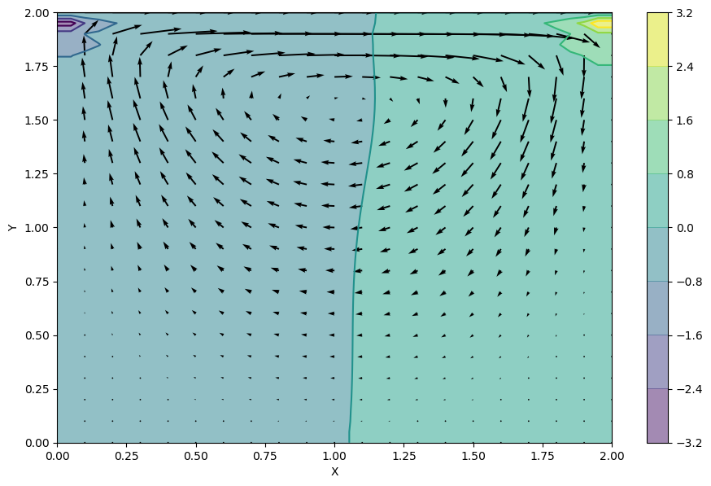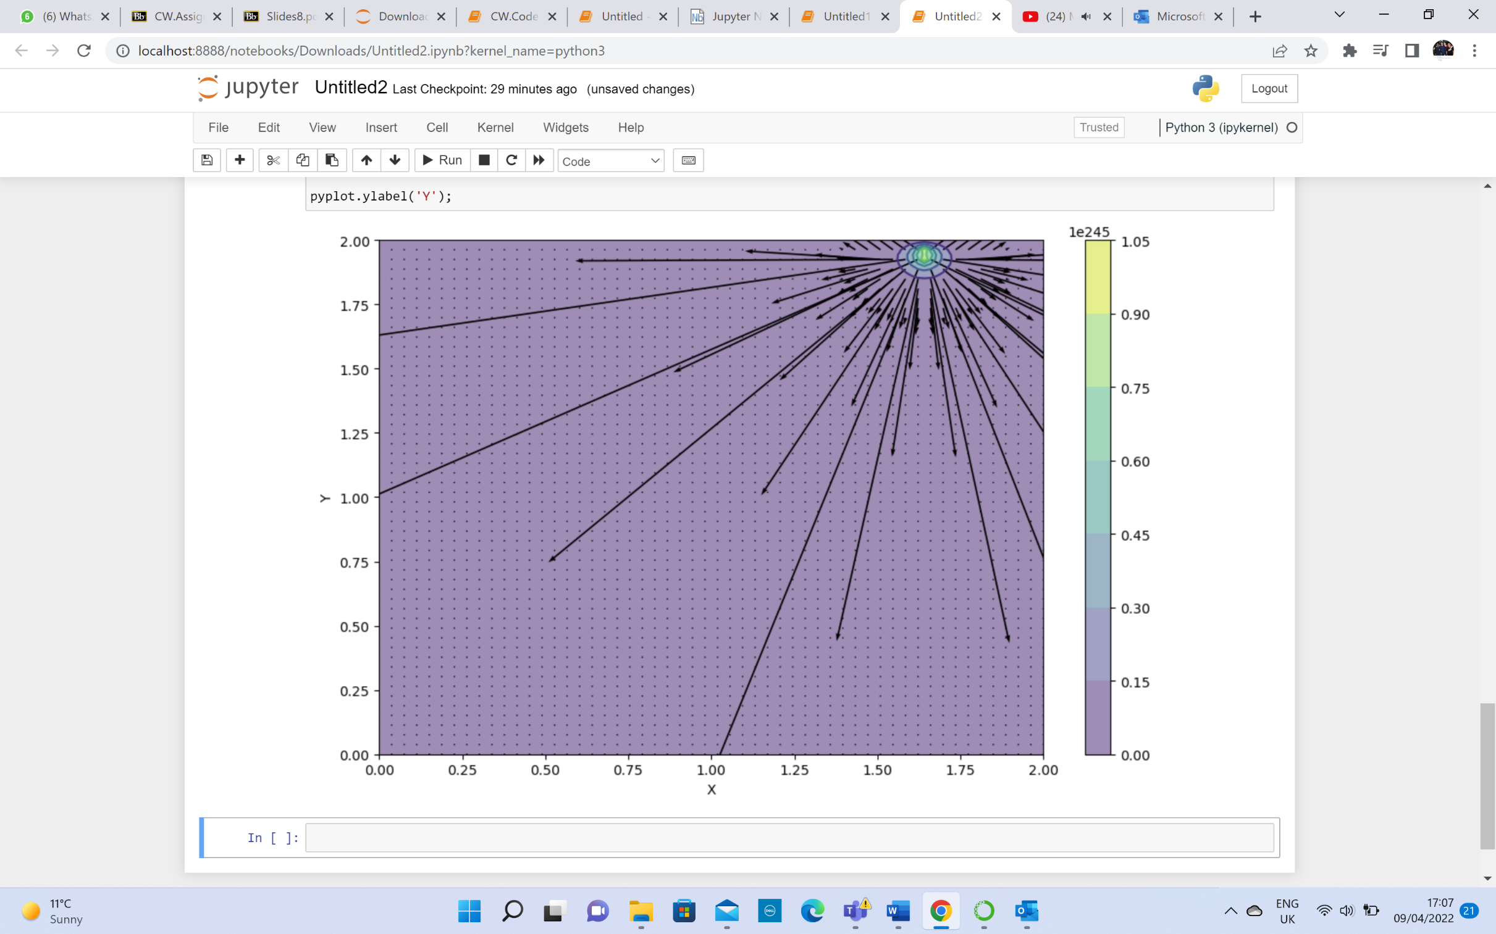**For kt = 700, (everything else constant)**

**For kx, ky = (10, 10), kt = 700, (and everything else constant)**

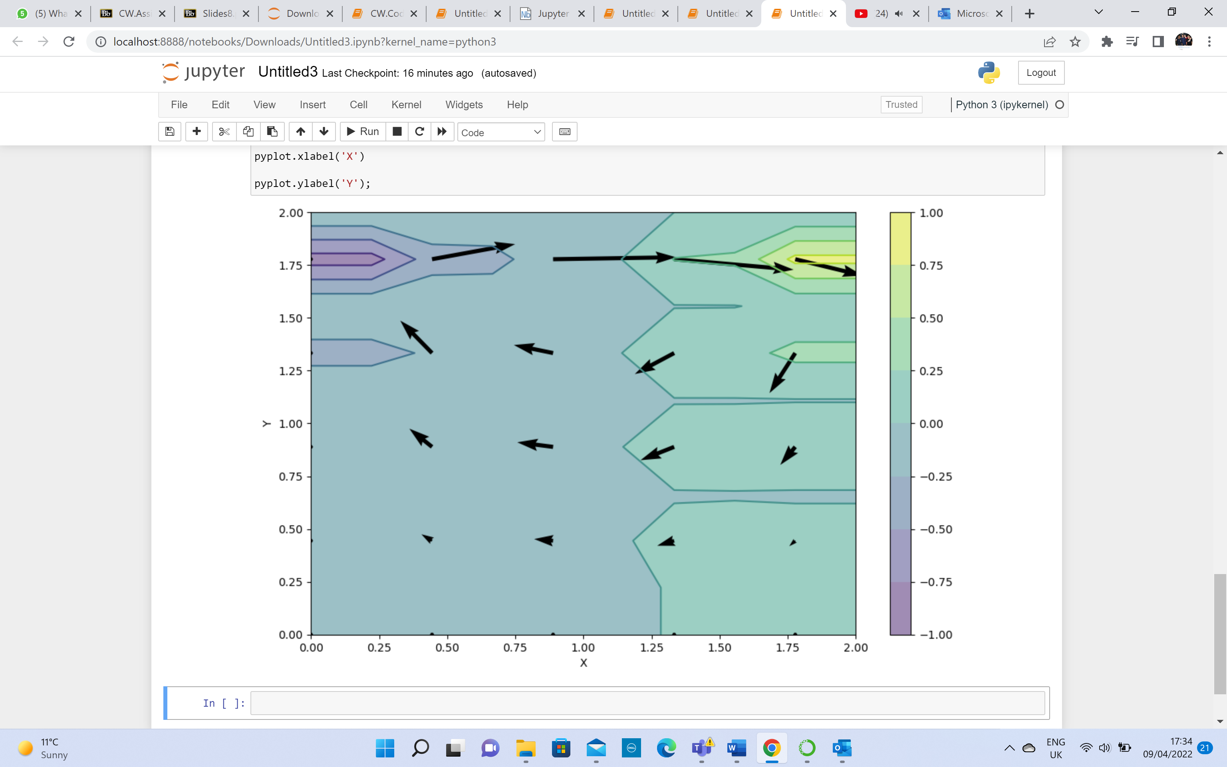

**For kx, ky = (81,81), kt = 700, (and everything else constant).**

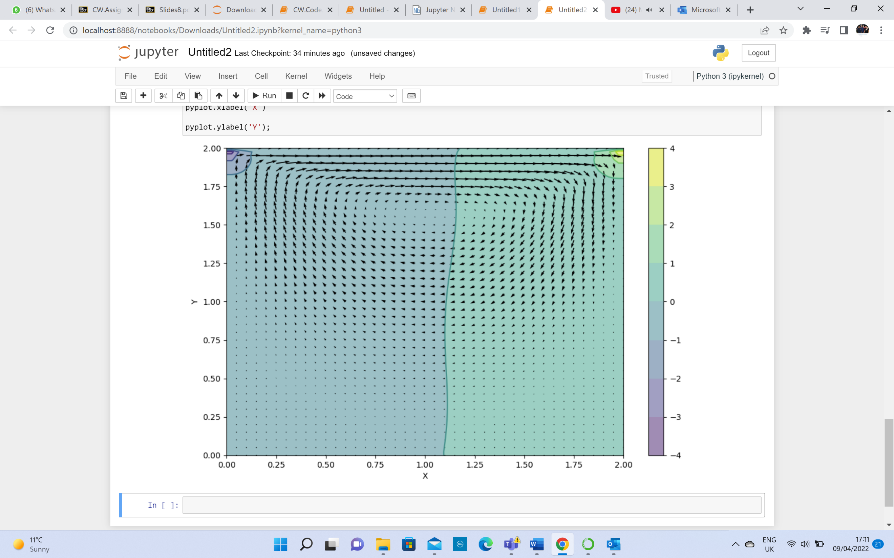

*As Kt is >> 100 (= 700), the change in kx and ky from 41 to 81 doesn’t make much difference to the diagram.*

**For kx, ky = (100, 100), kt = 700, (and everything else constant). (Threshold is kx, ky = (101,101)).**

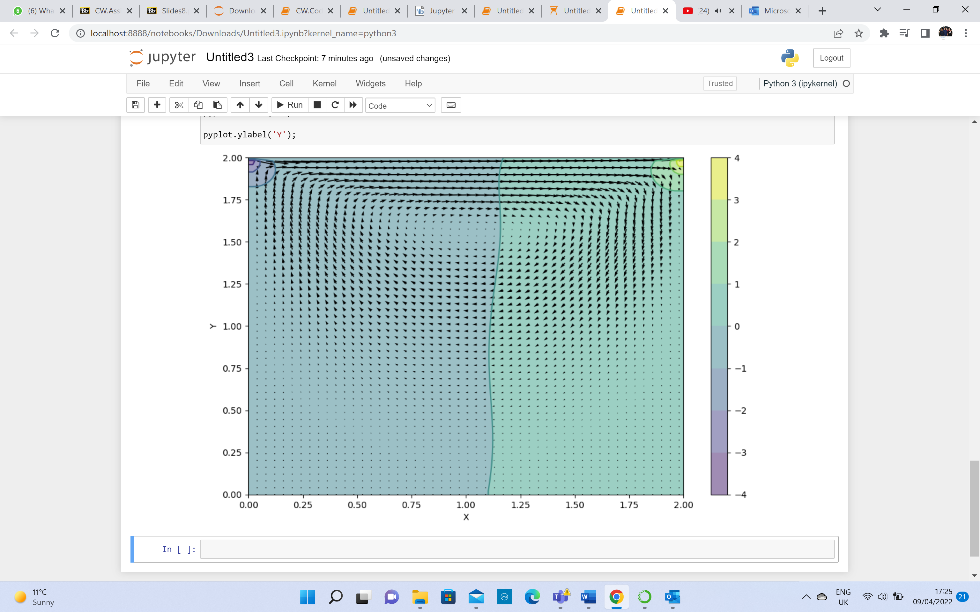

**For kx, ky = (101, 101), kt = 1000, (and everything else constant). (Threshold case: kx and ky above 101 will not work).**

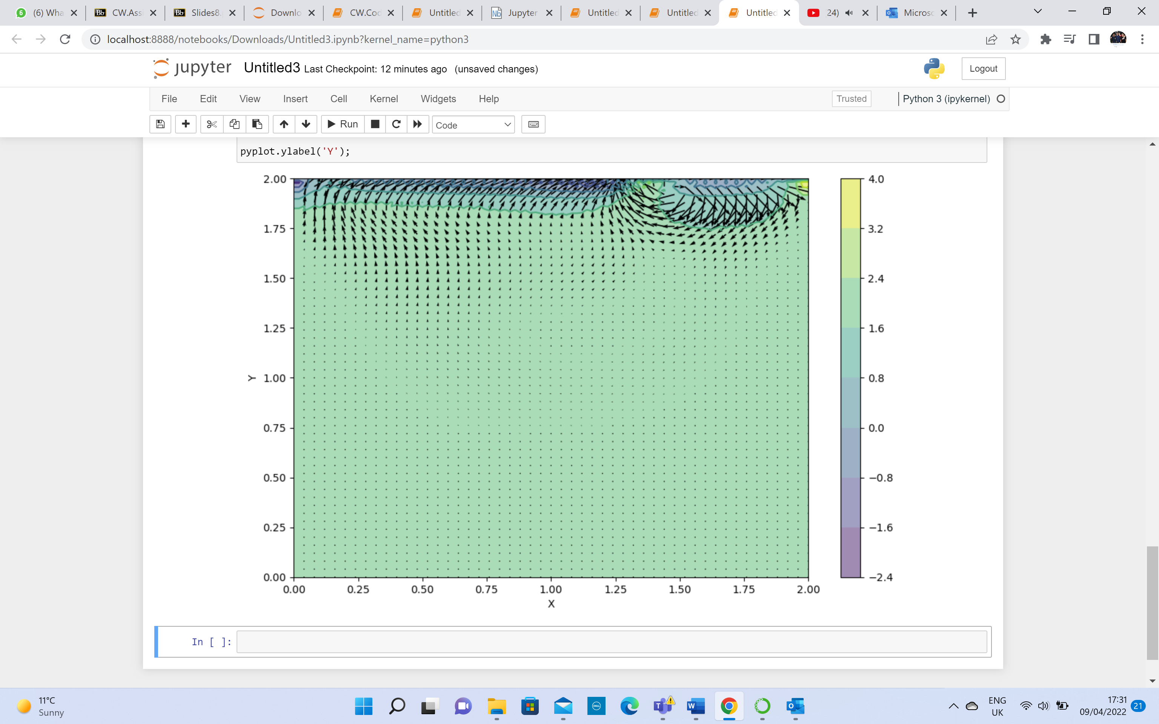

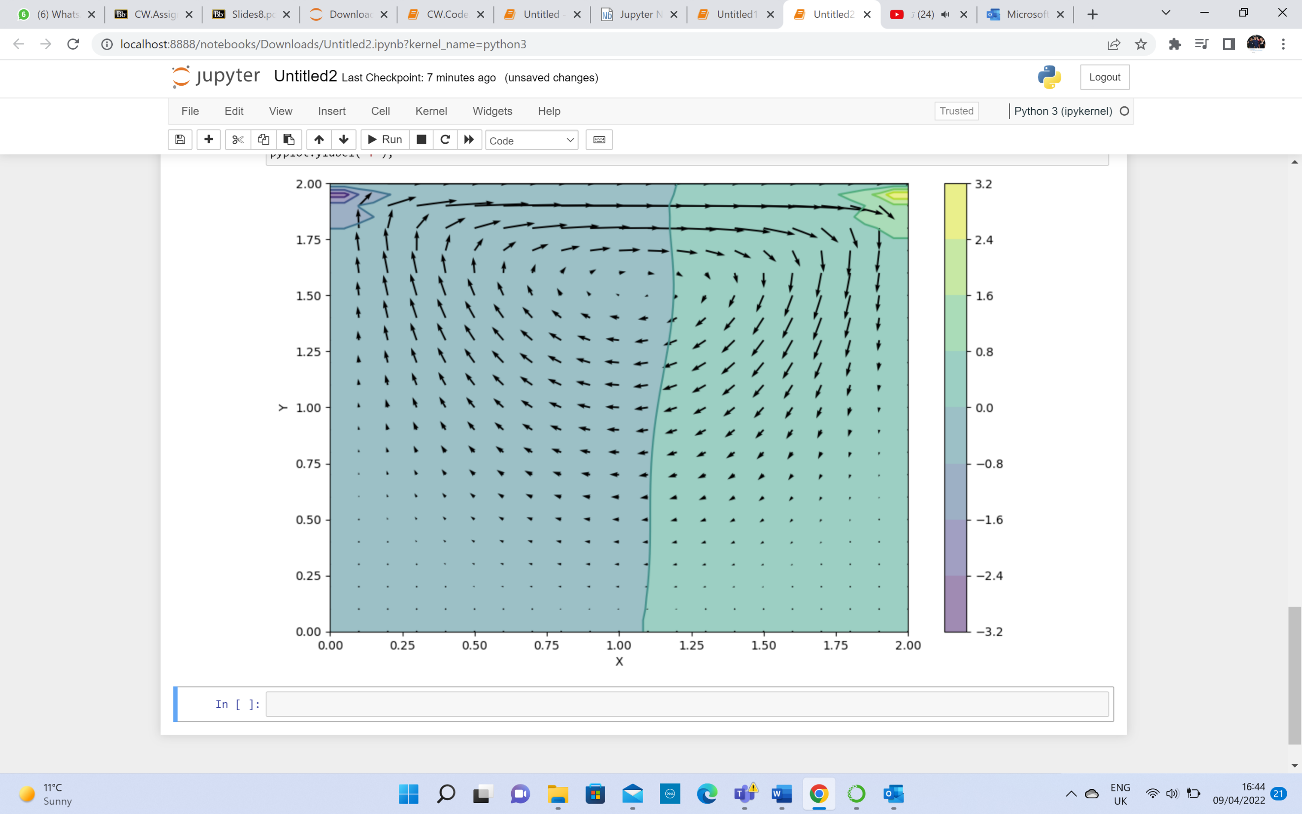**For kt = 1000, (everything else constant)**

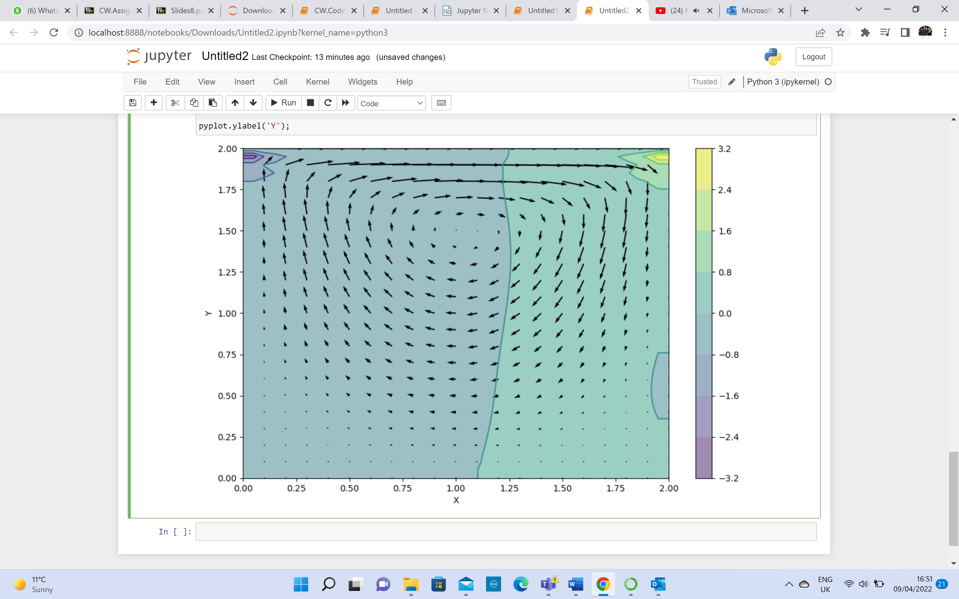**For kt = 10000, (everything else constant)**

Another way to visualize the flow in the cavity is to use a *streamplot*:

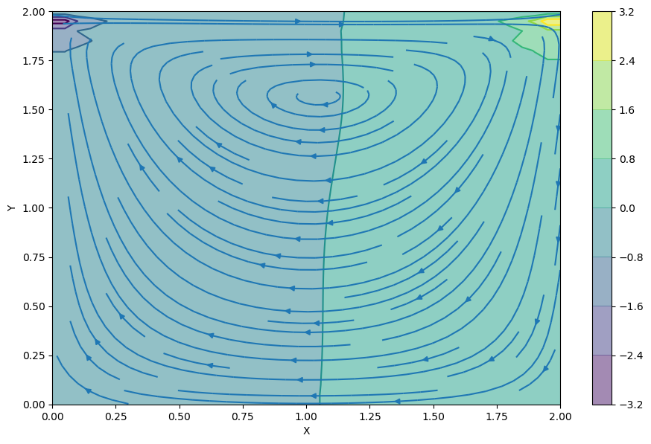

The quiver plot shows the magnitude of the velocity at the discrete points in the mesh grid we created. (We're actually only showing half of the points because otherwise it's a bit of a mess. The X[::2, ::2] syntax above is a convenient way to ask for every other point.)